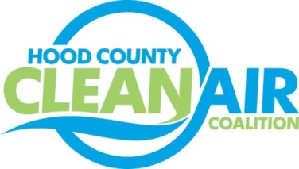
Meeting: Thursday, December 1, 2016
Neely House
304 East Rucker Street, Granbury, Texas 76048
8:30-10:00 a.m.

Agenda

- Call Meeting to Order
- EPA Updates – Randy Pitre
- Regional Updates – Michelle McKenzie
  - DFW Clean Cities Annual Meeting: December 6th, 1:30 PM, NCTCOG offices (www.dfwcleancities.org for details)
  - DFW Clean Cities Annual Report Data Collection
  - Hood County Clean Air Coalition Receives Air North Texas Partner Award for Outstanding Advertising (details: http://airnorthtexas.org/partners2016.asp)
  - Proposed Rulemaking “Implementation of the 2015 National Ambient Air Quality Standards for Ozone: Nonattainment Area Classifications and State Implementation Plan Requirements Published in Federal Register: https://www.gpo.gov/fdsys/pkg/FR-2016-11-17/pdf/2016-27333.pdf
  - Feedback Requested About Fleet Alternative Fuel Vehicle Obstacles and Procurement Plans Until the End of the Year: https://www.surveymonkey.com/r/FleetsFortheFuture
  - Air Quality Funding Opportunities for Vehicles
- Local Updates – Michelle McKenzie
  - Review of November Meeting Summary
  - Review of Projects
    - Monthly Budget Review for October
    - Status of Projects FY 16/17
  - Reports
    - November Ozone Update
    - Air North Texas Meeting
5.) Discussion
6.) Adjourn

